**Introduction to HTML and CSS Assignment**

**Exercise**

**1.How are inline and block elements different from each other?**

Block level

A **block-level** element always starts on a new line and takes up the full width available (stretches out to the left and right as far as it can).

Block level elements in HTML:

<address> <article> <aside> <blockquote> <canvas> <dd> <div> <dl>

<dt> <footer> <form> <h1>-<h6>

<header> <hr> <li> <main>

<ol> <output> <p> <pre>

<section> <table> <tfoot> <ul>

<video> <nav>

Inline Elements

An **inline element** does not start on a new line and only takes up as much width as necessary.

<a> <input> <acronym> <b>

<big> <br> button> <code>

<em> <i> <img> <label>

<script> <select> <small> <span>

<strong> <sub> <sup> <textarea>

<time> <tt> <var>

**2.Explain the difference between visibility:hidden and display:none**

**display:none** means that the tag in question will not appear on the page at all (although you can still interact with it through the dom). There will be no space allocated for it between the other tags.

**Visibility:hidden** means that unlike display:none, the tag is not visible, but space is allocated for it on the page. The tag is rendered, it just isn't seen on the page.

**Example:**

**test | <span style="[style-tag-value]">Appropriate style in this tag</span> | test**

**output:**

**test | | test**

**test | | test**

**3. Explain the clear and float properties.**

**Float:** float property is used to positioning and formatting content **eg:** logo and nav-bar positioning in any web page.

Properties:

float : left, float: right, float: none!

For example:

img {

float: right;

}

**Clear:** clear property specifies what elements can float beside the cleared element and on which side.

Properties:

clear : left, clear: right, clear: both!

For example:

div {

Clear: left;

}

**4. explain difference between absolute, relative,fixed and static.**

**CSS position property:**

The position property specifies the type of positioning method used for an element.

**position: absolute;**

An element with position: absolute; is positioned relative to the nearest positioned ancestor (instead of positioned relative to the viewport, like fixed).

However; if an absolute positioned element has no positioned ancestors, it uses the document body, and moves along with page scrolling.

**position: relative;**

An element with position: relative; is positioned relative to its normal position.

Setting the top, right, bottom, and left properties of a relatively-positioned element will cause it to be adjusted away from its normal position. Other content will not be adjusted to fit into any gap left by the element.

**position: fixed;**

An element with position: fixed; is positioned relative to the viewport, which

means it always stays in the same place even if the page is scrolled. The top, right, bottom, and left properties are used to position the element.

A fixed element does not leave a gap in the page where it would normally have been located.

**position: static;**

HTML elements are positioned static by default.

Static positioned elements are not affected by the top, bottom, left, and right

properties.

An element with position: static; is not positioned in any special way; it is always positioned according to the normal flow of the page.

**5. Write the HTML code to create a table in which there are 4 columns( ID , Employee Name, Designation, Department) and at least 6 rows. Also do some styling to it.**

**index.html**

<!DOCTYPE html>

<html>

<head>

<title>Table</title>

<link rel="stylesheet" type="text/css" href="style.css">

</head>

<body>

<table class="mytable">

<h1>Table</h1>

<tr>

<th>ID</th>

<th>Employee Name</th>

<th>Designation</th>

<th>Department</th>

</tr>

<tr>

<td>1</td>

<td>Kamal</td>

<td>Front End Developer</td>

<td>Production</td>

</tr>

<tr>

<td>2</td>

<td>Mudit</td>

<td>Front End Developer</td>

<td>Production</td>

</tr>

<tr>

<td>3</td>

<td>Joyesh</td>

<td>Front End Developer</td>

<td>Production</td>

</tr>

<tr>

<td>4</td>

<td>Shivangi</td>

<td>Java Developer</td>

<td>Production</td>

</tr>

<tr>

<td>5</td>

<td>Sukirti</td>

<td>Java Developer</td>

<td>Production</td>

</tr>

</table>

</body>

</html>

**style.css**

table{

width: 100%;

}

table, th, td{

border: 1px solid black;

border-collapse: collapse;

}

th, td{

padding: 15px;

text-align: left;

}

th{

background-color: #48A1EC;

color: white;

text-align: center;

}

h1{

text-align: center;

color: #0182EF;

margin: 20px auto;

}

.mytable{

margin: 20px auto;

}

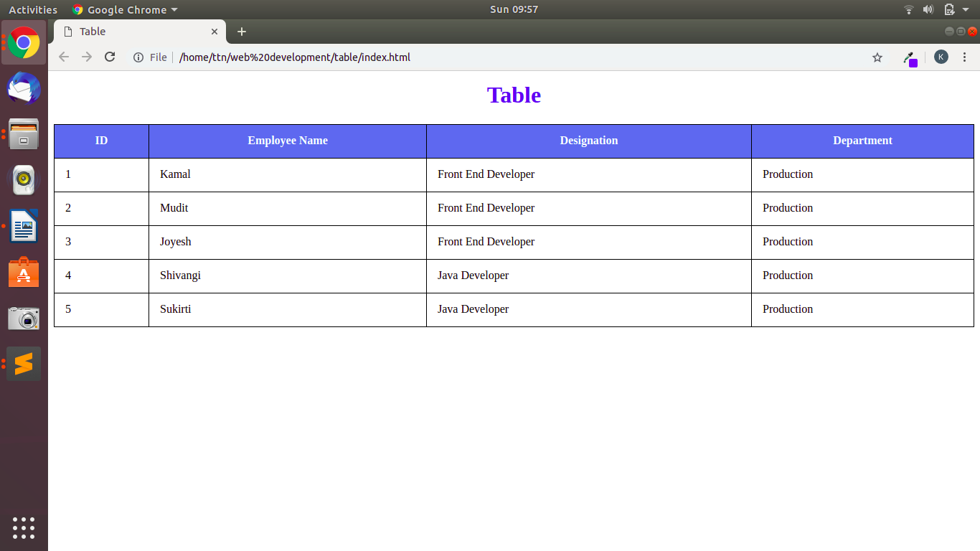

**For mobile or tablet:**

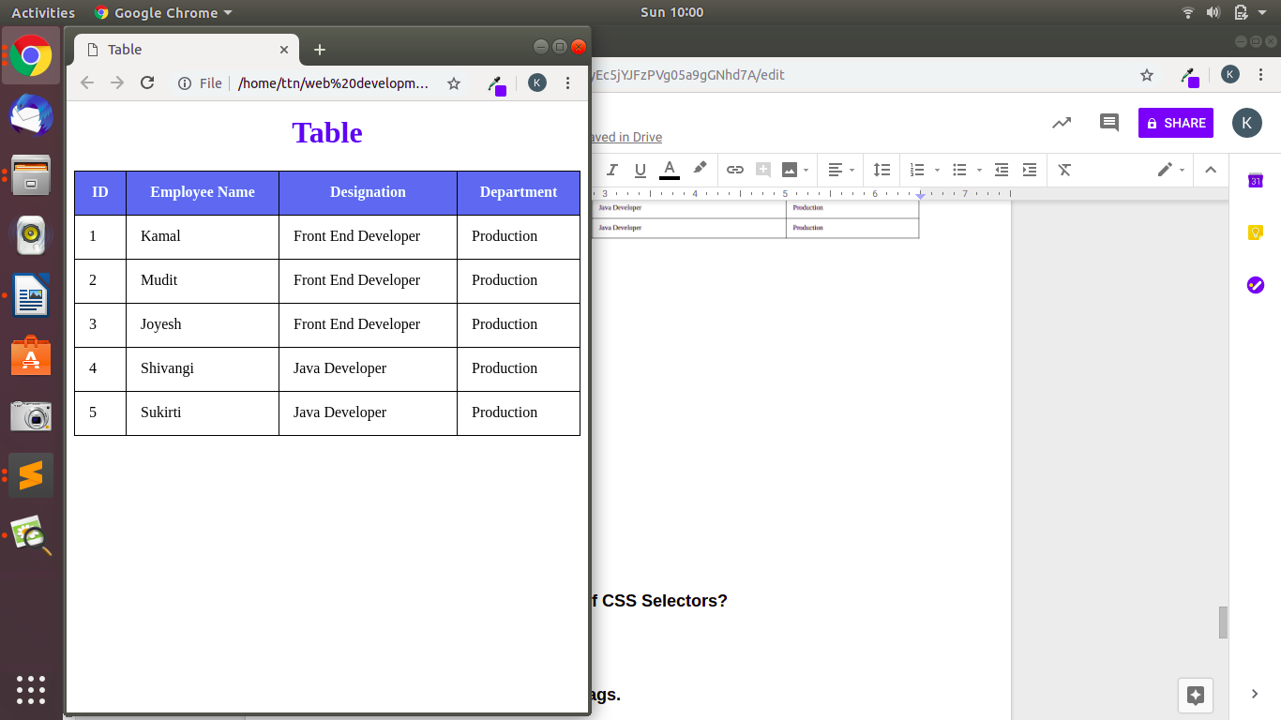

**6. Why do we use meta tags?**

The <meta> tag provides metadata about the HTML document. Metadata will not be displayed on the page, but will be machine parsable.

Meta elements are typically used to specify page description, keywords, author of the document, last modified, and other metadata.

The metadata can be used by browsers (how to display content or reload page), search engines (keywords), or other web services.

HTML5 introduced a method to take control over the viewport (the user's visible area of a web page).

meta tag is also used for SEO (Search engine optimization) purpose to set the keywords for any specific page.

For example:

<meta name="author" content="kamal">

**7. Explain box model.**

The CSS box model is essentially a box that wraps around every HTML element. It consists of: margins, borders, padding, and the actual content.

* **Margin** - Clears an area outside the border. The margin is transparent
* **Border** - A border that goes around the padding and content
* **Padding** - Clears an area around the content. The padding is transparent
* **Content** - The content of the box, where text and images appear.

The box model allows us to add a border around elements, and to define space between elements.

For example:

div {

width: 300px;

border: 25px solid green;

padding: 25px;

margin: 25px;

}

**8. What are the different types of CSS Selectors?**

**CSS Selector:**

CSS selectors are used to select the content you want to style. Selectors are the part of CSS rule set. CSS selectors select HTML elements according to its id, class, type, attribute etc.

There are several different types of selectors in CSS:

1. CSS Element Selector
2. CSS Id Selector
3. CSS Class Selector

**For example:**

CSS Element Selector:

p{

text-align: center;

color: blue;

}

CSS Id Selector:

#para1 {

text-align: center;

color: blue;

}

CSS Class Selector:

.center {

text-align: center;

color: blue;

}

**9. Define Doctype.**

The <!DOCTYPE> declaration must be the very first thing in your HTML document, before the <html> tag.

The <!DOCTYPE> declaration is not an HTML tag, it is an instruction to the web browser about what version of HTML the page is written in.

For example:

<!DOCTYPE html>

<html>

<head>

<title>Title of the document</title>

</head>

<body>

The content of the document......

</body>

</html>

**10. Explain 5 HTML5 semantic tags.**

* **HTML5 <section> Element:**

The <section> element defines a section in a document. A section is grouping of content, typically with a heading. A home page could normally be split into sections for introduction, content, and contact information.

For example:

<section>

<h1>TTN<h1>

<p>To The New…….</p>

</section>

* **HTML5 <article> Element**

The <article> element specifies independent, self-contained content. An article should make sense on its own, and it should be possible to read it independently from the rest of the web site. It can be used for a forum post, blog post or a newspaper article.

For example:

<article>

<h1>TTN<h1>

<p>To The New…….</p>

</article>

* **HTML5 <header> Element**

The <header> element specifies a header for a document or section. The <header> element should be used as a container for introductory content. You can have several <header> elements in one document.

For example:

<html>

<body>

<header>

<h1>TTN<h1>

<p>To The New </p>

</header>

<p>A digital technology company</p>

</body>

</html>

* **HTML5 <footer> Element**

The <footer> element specifies a footer for a document or section. A <footer> element should contain information about its containing element. A footer typically contains the author of the document, copyright information, links to terms of use, contact information, etc. You may have several <footer> elements in one document.

For example:

<footer>

<p>Posted by: Joyesh Malik</p>

<p>Contact information: <a href="mailto:joyesh.malik@tothenew.com">

joyesh.malik@tothenew.com</a>.</p>

</footer>

* **HTML5 <nav> Element**

The <nav> element defines a set of navigation links.

For example:

<nav>

<a href="/html/">HTML</a> |

<a href="/css/">CSS</a> |

<a href="/js/">JavaScript</a>

</nav>

**11. Create HTML for web-page.jpg (check resources, highest weightage for answers)**

index.html

<!DOCTYPE html>

<html>

<head>

<title>Home Page</title>

<link rel="stylesheet" type="text/css" href="style.css">

</head>

<body>

<div class="container">

<header>

<h2><a href="#">To the New</a></h2>

<nav>

<ul>

<li><a href="#">TEXT LINK</a></li>

<li><a href="#">TEXT LINK</a></li>

<li><a href="#">TEXT LINK</a></li>

<li><a href="#">TEXT LINK</a></li>

<li><a href="#">TEXT LINK</a></li>

</ul>

</nav>

</header>

<div class="inner-block">

<center>

<div class="slider">

<img src="work-area_960x360.jpg" >

</div></center>

<center>

<div class="content">

<p id="p_spacing">VESTIBULUMACCUMSAN EGESTIBULUM EU JUSTO CONVALLIS AUGUE ESTAS AENEAN ELIT INTESQUE SED.</p>

<p>FACILISPEDE ESTIBULUM NULLA ORNA NISL VELIT ELIT AC ALIQUAT NON TINCIDUNT NAMJUSTO CRAS URNA.</p>

</div>

</center>

<div class="gallery-main-content">

<h3>LATEST FROM THE GALLERY</h3>

<hr>

</div>

<center>

<div class="gallery">

<div class="gallery-content">

<img src="tothenew.jpg">

<div class="gallery-image-title">

To The New

</div>

</div>

<div class="gallery-content">

<img src="tothenew.jpg">

<div class="gallery-image-title">

To The New

</div>

</div>

<div class="gallery-content">

<img src="tothenew.jpg">

<div class="gallery-image-title">

To The New

</div>

</div>

<div class="gallery-content">

<img src="tothenew.jpg">

<div class="gallery-image-title">

To The New

</div>

</div>

</div>

</center>

</div>

<footer>

<div id="copyright">Copyright &copy; 2009-2017-All Rights Reserved-To the new</div>

<div id="credit">

Web layout by To the new

</div>

</footer>

</div>

</body>

</html>

style.css

body{

background-color: #393939;

color: #ffffff;

margin: 0 50px;

}

.container{

background-clip: #353535;

border: 1px solid gray;

}

header{

margin: 10px 120px;

}

nav{

background-color: #262626;

padding: 1px;

}

li{

list-style-type: none;

display: inline;

padding-right: 30px;

}

.inner-block{

background-color: #ffffff;

padding: 20px;

}

.slider{

background-color: #353535;

width: 960px;

height: 360px;

}

footer{

padding: 10px;

}

#credit{

float: right;

}

.content{

width: 960px;

height: auto;

background-color: #ededed;

text-align: justify;

margin: 20px;

text-align: left;

padding: 1px 0;

}

.content p{

margin-left: 10px;

color: gray;

}

#p_spacing{

word-spacing: 10px;

}

.gallery{

max-width: 960px;

margin: auto;

overflow: auto;

color: #000000;

}

.gallery-content{

margin: 10px;

border: 1px solid #ccc;

float: left;

width: 215px;

}

.gallery-content img{

width: 100%;

height: 315px;

}

.gallery-main-content{

width: 960px;

color: #000000;

padding-left: 90px;

}

.gallery-image-title{

background-color: #ededed;

border: 2px solid white;

padding: 5px;

}

#copyright{

padding-left: 100px;

float: left;

}

#credit{

float: right;

margin-right: -100px;

}

footer{

margin-bottom: 15px;

width: 960px;

}

a{

text-decoration: none;

color:#ffffff;

}

@media screen and (max-width : 760px){

.container{

width: auto;

height: auto;

}

.slider{

width: 100%;

height: auto;

}

.gallery{

width: 100%;

height: auto;

padding-left: 60px;

}

.slider img{

width: 100%;

}

.content{

width: 100%;

padding: auto;

margin: 10px 0 0 0;

}

.gallery-main-content{

width: 100%;

color: #000000;

padding-left: 0;

text-align: center;

}

.footer{

width:100%;

}

#copyright{

padding-left: 0;

float: none;

}

#credit{

float: none;

margin-top: 10px;

}

h2{

text-align: center;

}

body{

width: auto;

}

nav{

text-align: center;

}

}

Output:

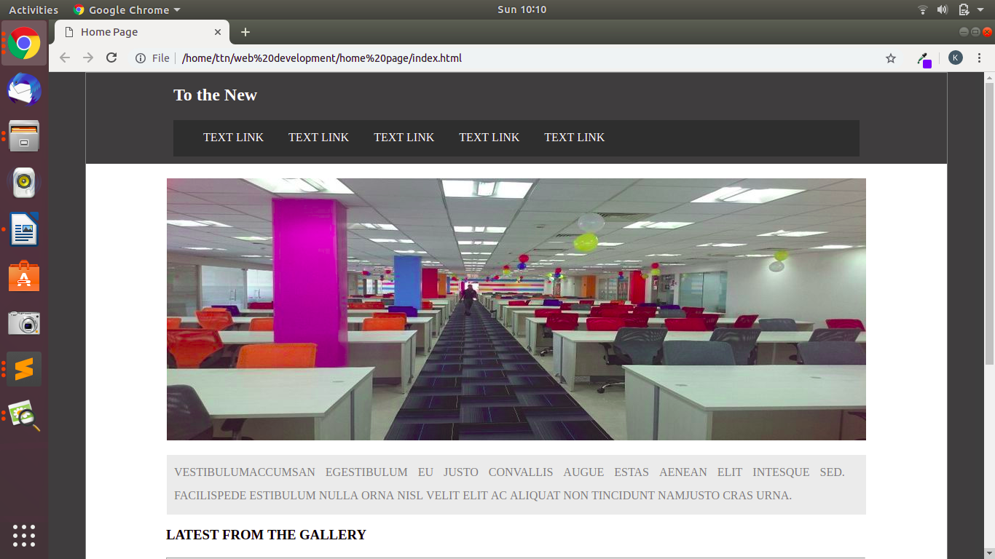

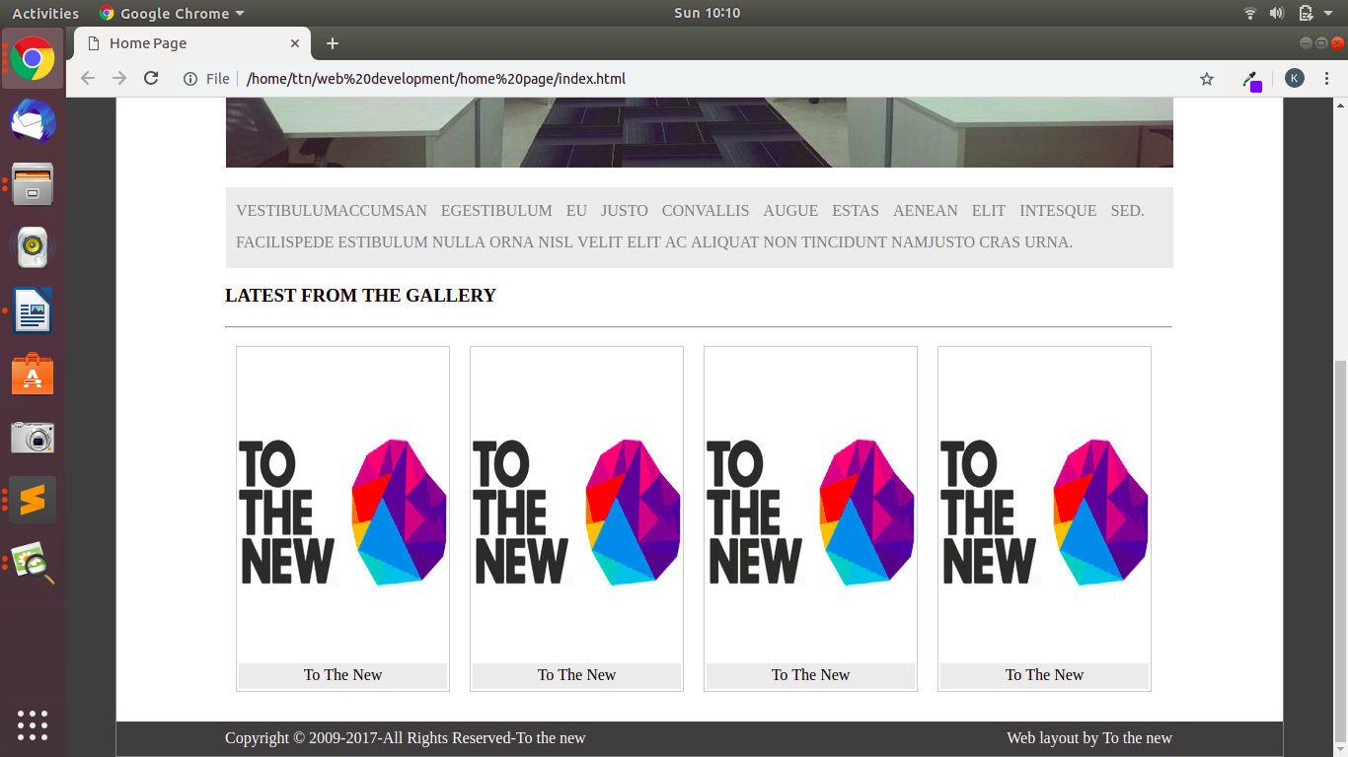

**Mobile:**

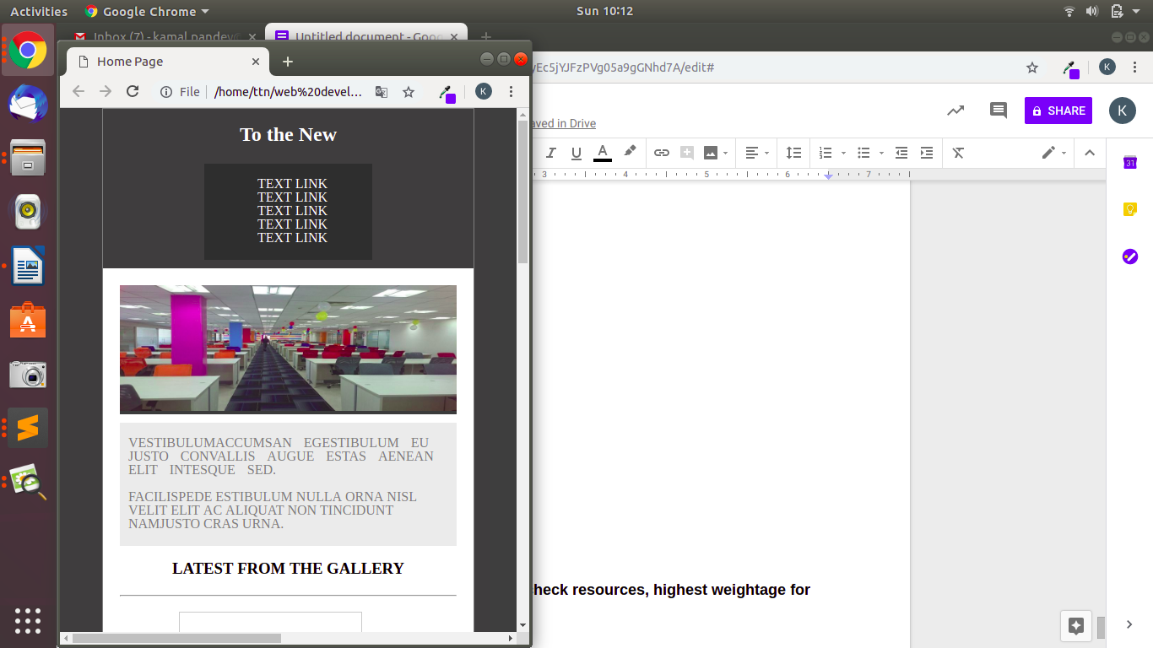

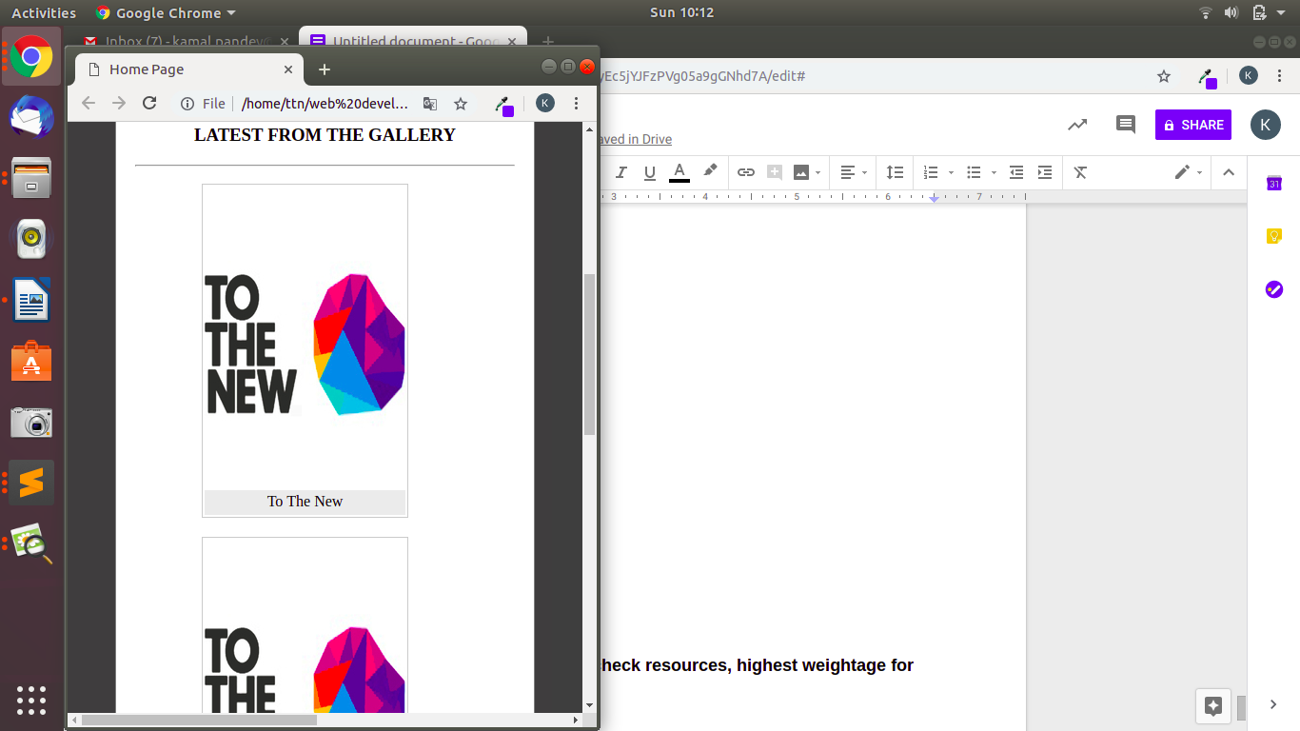

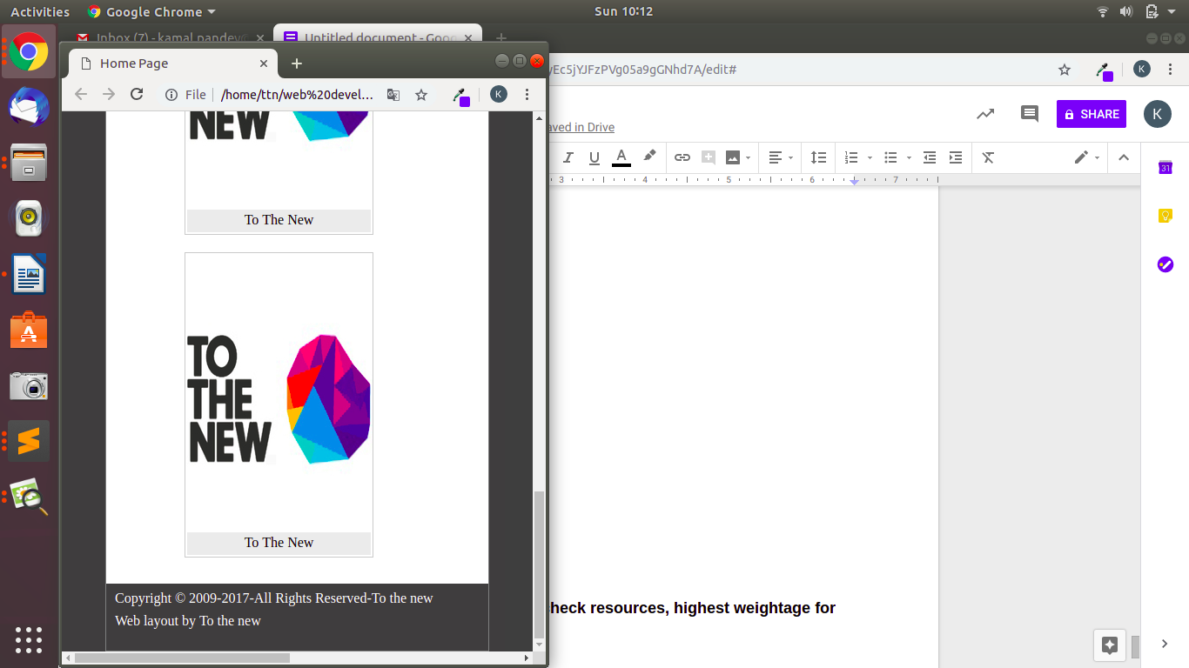

**12. Create HTML for form.png (check resources, highest weightage for answers)**

**index.html**

<!DOCTYPE html>

<html>

<head>

<title>Bug Form</title>

<link rel="stylesheet" type="text/css" href="style.css">

</head>

<body>

<header>

<nav>

<div id="logo"><a href="#">TO THE NEW</a></div>

<div id = navbar>

<ul>

<li><a href="#">Home</a></li>

<li><a href="#">Quick Help</a></li>

</ul>

</div>

</nav>

</header>

<div class="container">

<form action="#" method="get">

<div class="form-head">Bug Report</div>

<div class="form-body">

<div class="title">

Title:* <br>

<input type="text" name="title" required="required">

</div>

<div class="Description">

Description:* <br>

<textarea></textarea>

</div>

<div class="dropdown">

Operating System: <br>

<select name="os">

<option value="Window">Windows XP</option>

<option value="linux">Linux</option>

<option value="mac">Mac</option>

</select>

</div>

<div class="dropdown">

Product:* <br>

<select name="product">

<option value="formoid">Formoid</option>

<option value="test">test</option>

<option value="test">test</option>

</select>

</div>

<div class="version">

Version:* <br>

<input type="text" name="Version" required="required">

</div>

<div class="licence">

Licence:

<br />

<input type="radio" name="licence" value="free">Free

<input type="radio" name="licence" value="Business" id ="licence-center">Business

</div>

<div class="dropdown">

Severity:<br>

<select name="Severity">

<option value="Critical">Critical</option>

<option value="test">test</option>

<option value="test">test</option>

</select>

</div>

<div class="Attachments">

Attachments: <br />

<input type="text" name="Attachments" placeholder="No file selected"> <button type="button">Choose File</button>

</div>

</div>

<div class="form-footer">

<button type="submit" id="footer-button">Send</button>

</div>

</form>

</div>

</body>

</html>

**style.css**

body{

margin: 0;

padding: 0 125px;

}

header {

border-bottom: 1px solid gray;

}

#navbar{

float: right;

padding: 5px 0;

}

#logo{

float: left;

padding:20px 0;

color: #009997;

font-size: 20px;

}

#logo a{

text-decoration: none;

color:#009997;

font-size: 20px;

}

header::after{

content: '';

display: table;

clear: both;

}

li{

display: inline-block;

padding-left: 20px;

}

li a{

color: #009997;

text-decoration: none;

}

li a:hover{

color:blue;

font-size: 20px;

}

.container{

margin: 10px 250px;

border: 1px solid gray;

border-radius: 5px;

}

.form-head{

margin: 0;

background-color: #a5b1ae;

font-size: 25px;

padding: 15px;

color:white;

font-weight: bold;

}

.form-footer{

margin: 0;

background-color: #c1d6d2;

}

#footer-button{

font-size: 15px;

float: right;

color: white;

background-color: #00c89e;

padding: 10px;

margin: 10px 20px;

border-radius: 5px;

font-weight: bold;

border: 1px solid #00c89e;

}

.form-footer::after{

content: '';

display: table;

clear: both;

}

.form-body{

padding: 10px 20px;

font-size: 15px;

}

.title input{

width: 100%;

height: 20px;

margin-bottom: 10px;

border-radius: 4px;

border: 1px solid gray;

}

.description{

}

.Description textarea{

width: 100%;

height: 70px;

margin-bottom: 10px;

border-radius: 4px;

border: 1px solid gray;

}

.dropdown select{

width: 100%;

height: 35px;

margin-bottom: 10px;

border-radius: 4px;

border: 1px solid #00c89e;

background-color: #00c89e;

color: #ffffff;

font-size: 15px;

font-weight: bold;

}

.version input{

margin-bottom: 10px;

width: 20%;

height: 20px;

border-radius: 4px;

border: 1px solid gray;

}

.licence {

margin-bottom: 10px;

}

.Attachments input{

height: 20px;

width: 75%;

border-top-left-radius: 4px;

border-bottom-left-radius: 4px;

border: 1px solid gray;

padding: 4px;

}

.Attachments button{

height: 30px;

width: 22%;

margin-left: -4px;

margin-top: -10px;

border-top-right-radius: 4px;

border-bottom-right-radius: 4px;

border: 1px solid gray;

color: #ffffff;

font-weight: bold;

background-color: gray;

}

#licence-center{

margin-left: 40%;

}

@media screen and (max-width : 760px){

#navbar{

float: right;

padding: 5px 0;

width: 100%;

}

#logo{

margin-left: 60px;

float: left;

padding:20px 0;

color: #009997;

font-size: 20px;

}

.container{

margin: 10px 0 0 0 ;

border: 1px solid gray;

border-radius: 5px;

}

.Attachments input{

height: 20px;

margin-top: 10px;

width: 70%;

border-top-left-radius: 4px;

border-bottom-left-radius: 4px;

border: 1px solid gray;

padding: 4px;

}

.Attachments button{

height: 30px;

width: 25%;

border-top-right-radius: 4px;

border-bottom-right-radius: 4px;

border: 1px solid gray;

color: #ffffff;

font-weight: bold;

background-color: gray;

}

.version input{

margin-bottom: 10px;

width: 40%;

height: 20px;

border-radius: 4px;

border: 1px solid gray;

}

}

**Output:**

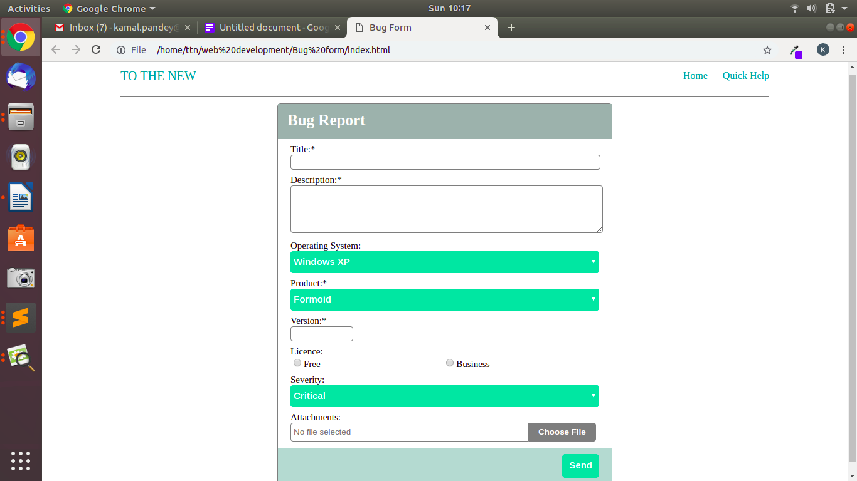

**Mobile:**

